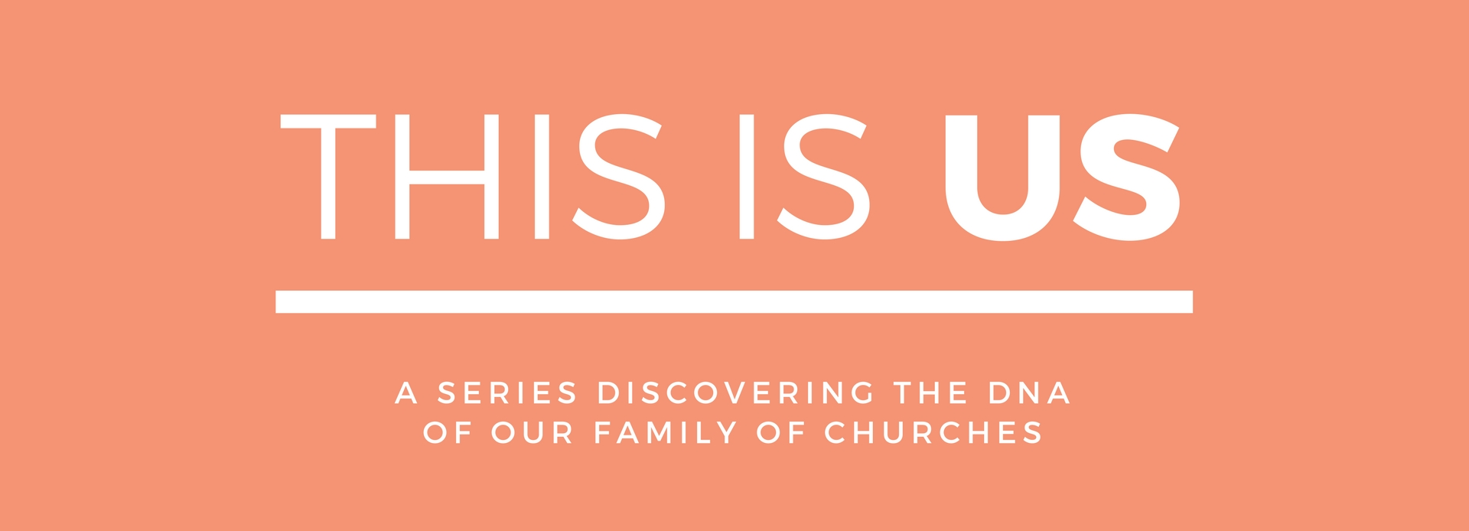

LIFE GROUPS – From Rows To Circles
Life Groups are our midweek groups that are smaller and more than our Sundays gatherings. On Sundays we sit in rows but in our small groups we sit in circles – getting to know each other better, building deeper friendships and sharing our lives. We gather in homes across Colchester and have lots of fun while learning and sharing about God, His Word and our lives and the mission we are on.

SERIES DESCRIPTION
Redeemer is part of a family of churches called ‘Relational Mission’ and consequently carries the same family ‘DNA.’ Mike Betts is the apostolic leader of Relational Mission, or you might say the ‘father of the family of churches’ and he has written a book highlighting the core DNA of Relational Mission and subsequently all the churches within the network/family. This ‘DNA’ gets expressed differently depending on various circumstances and how that is don is not prescriptive – each family has its own expression of this ‘culture’. This series unpacks what this DNA is and how we outwork it.

WEBSITE
You can read more about the series and catch up on sermons on our website. Go to redeemerchurchcolchester.org/thisisus.

THE BOOK
Mike Betts’ book ‘Relational Mission – A Way Of Life’ is available at church on Sundays or can be ordered from amazon here.

SERIES SCHEDULE
#1 23.04,17 A REAL FAMILY
#2 30.04.17 RAISING SONS & DAUGHTERS
#3 07.05.17 EVERYONE A WITNESS
#4 14.05.17 THE PRAYERS OF MANY
#5 21.05,17 CHURCH FOR A BROKEN WORLD
#6 28.05.17 STARTING NEW FAMILIES
#7 04.06.17 WE HAVE A COMPASS NOT A MAP
#8 11.06.17 GLOBAL SUNDAY ROAD-TRIP EXPERIENCE
#9 18.06.17 TOGETHER'17 FESTIVAL IMMERSION

THIS IS US LIFE GROUP NOTES
WEEK 2 – RAISING SONS & DAUGHTERS
30.04.17

OVERVIEW
RAISING SONS & DAUGHTERS – as the church family is purposeful and has a mission that will continue until beyond our generation and until Jesus comes, the importance of raising ‘sons and daughters’ is vital. How do we do that? Psalm 127 compares children to arrows - how can that help us understand what raising sons & daughters looks like?

SCRIPTURE
Psalm 127:4 ESV ⁴Like arrows in the hand of a warrior are the children of one's youth.

- Joshua 2:8-12a // 2 Tim 3:10 // Hebrews 10:24-25

MAIN POINTS
CHILDREN ARE LIKE ARROWS – they need to be carefully made, are weapons of war and can go further and faster than us.

- ENGAGE WITH OTHERS PROACTIVELY because arrows need to be carefully made
  - Pour your life into someone and pursue someone
- ENCOURAGE OTHERS PURPOSEFULLY because arrows are weapons of war
- ENTRUST OTHERS DELIBERATELY because arrows go further and faster than us

QUESTIONS
- What struck you about the preach?
- Who are you/could you pour your life into? (Discipling)
  - What does that look like?
- Who are you pursuing/asking to speak into your life? (Being disciple)
  - A spiritual Mother or Father?
  - Peers?
- Who can you encourage purposefully this week and ongoingly?
- In what way can you entrust others or help others grow?

