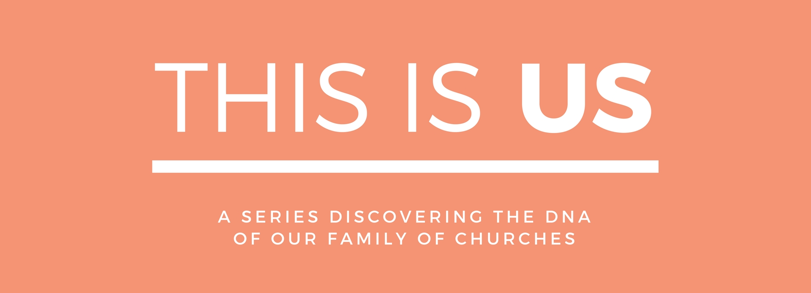

LIFE GROUPS – From Rows To Circles
Life Groups are our midweek groups that are smaller and more than our Sundays gatherings. On Sundays we sit in rows but in our small groups we sit in circles – getting to know each other better, building deeper friendships and sharing our lives. We gather in homes across Colchester and have lots of fun while learning and sharing about God, His Word and our lives and the mission we are on.

SERIES DESCRIPTION
Redeemer is part of a family of churches called ‘Relational Mission’ and consequently carries the same family ‘DNA.’ Mike Betts is the apostolic leader of Relational Mission, or you might say the ‘father of the family of churches’ and he has written a book highlighting the core DNA of Relational Mission and subsequently all the churches within the network/family. This ‘DNA’ gets expressed differently depending on various circumstances and how that is done is not prescriptive – each family has its own expression of this ‘culture’. This series unpacks what this DNA is and how we outwork it.

WEBSITE
You can read more about the series and catch up on sermons on our website. Go to redeemerchurchcolchester.org/thisisus.

THE BOOK
Mike Betts’ book ‘Relational Mission – A Way Of Life’ is available at church on Sundays or can be ordered from amazon here.

SERIES SCHEDULE
#1 23.04,17 A REAL FAMILY
#2 30.04.17 RAISING SONS & DAUGHTERS
#3 07.05.17 EVERYONE A WITNESS
#4 14.05.17 THE PRAYERS OF MANY
#5 21.05,17 CHURCH FOR A BROKEN WORLD
#6 28.05.17 STARTING NEW FAMILIES
#7 04.06.17 WE HAVE A COMPASS NOT A MAP
#8 11.06.17 GLOBAL SUNDAY ROAD-TRIP EXPERIENCE
#9 18.06.17 TOGETHER'17 FESTIVAL IMMERSION

THIS IS US LIFE GROUP NOTES
WEEK 3 – EVERYONE A WITNESS
07.05.17

OVERVIEW
Everyone a Witness

MAIN POINTS

- Everyone is Called to Be a Witness.
- Develop a Lifestyle of Obedience.
- Learn to Rely on the Holy Spirit.

QUESTIONS

- Share some examples of occasions where you have had a positive response from a person you spoke to or served in some way.

- What do you think are the stumbling blocks that prevent you from being obedient to God? Pray for each other that obedience to God will become more prevalent in your daily living.

- Would you say that you have been baptised in the Holy Spirit? Share what happened. If you are not sure/would like to be, then pray together asking Jesus to baptise you in the Holy Spirit.

